**Find Your Colonial Relatives**

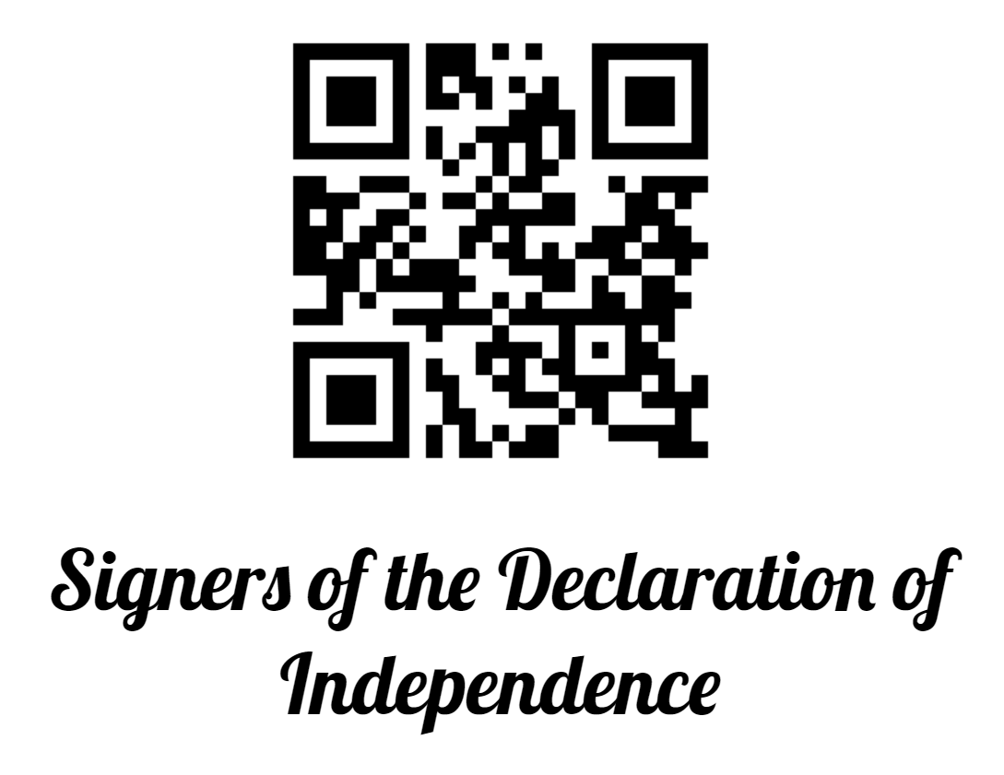

Scan this QR code to open our website to see how you are related. If you have a FamilySearch.org account, you can search as yourself. If not, you can find a deceased ancestor (such as your grandfather) and search as that person.

If you need help getting started, go to map location #2, and someone will be happy to help.

**Find Your Colonial Relatives**

Scan this QR code to open our website to see how you are related. If you have a FamilySearch.org account, you can search as yourself. If not, you can find a deceased ancestor (such as your grandfather) and search as that person.

If you need help getting started, go to map location #2, and someone will be happy to help.

**Find Your Colonial Relatives**



Scan this QR code to open our website to see how you are related. If you have a FamilySearch.org account, you can search as yourself. If not, you can find a deceased ancestor (such as your grandfather) and search as that person.

If you need help getting started, go to map location #2, and someone will be happy to help.

**Find Your Colonial Relatives**



Scan this QR code to open our website to see how you are related. If you have a FamilySearch.org account, you can search as yourself. If not, you can find a deceased ancestor (such as your grandfather) and search as that person.

If you need help getting started, go to map location #2, and someone will be happy to help.

**Find Your Colonial Relatives**



Scan this QR code to open our website to see how you are related. If you have a FamilySearch.org account, you can search as yourself. If not, you can find a deceased ancestor (such as your grandfather) and search as that person.

If you need help getting started, go to map location #2, and someone will be happy to help.

**Find Your Colonial Relatives**



Scan this QR code to open our website to see how you are related. If you have a FamilySearch.org account, you can search as yourself. If not, you can find a deceased ancestor (such as your grandfather) and search as that person.

If you need help getting started, go to map location #2, and someone will be happy to help.

**Find Your Colonial Relatives**



Scan this QR code to open our website to see how you are related. If you have a FamilySearch.org account, you can search as yourself. If not, you can find a deceased ancestor (such as your grandfather) and search as that person.

If you need help getting started, go to map location #2, and someone will be happy to help.

**Find Your Colonial Relatives**



Scan this QR code to open our website to see how you are related. If you have a FamilySearch.org account, you can search as yourself. If not, you can find a deceased ancestor (such as your grandfather) and search as that person.

If you need help getting started, go to map location #2, and someone will be happy to help.

**Find Your Colonial Relatives**

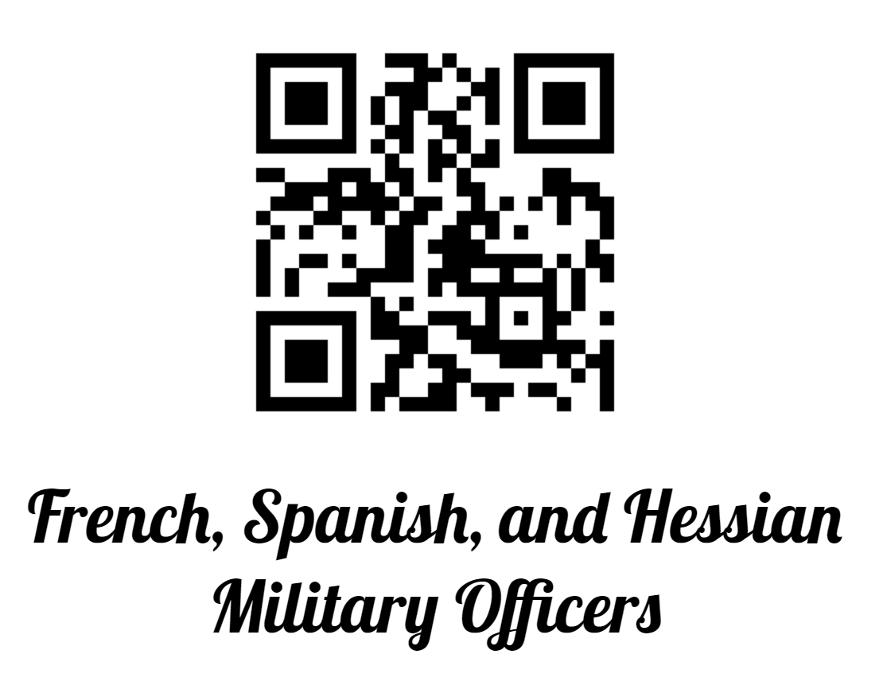

Scan this QR code to open our website to see how you are related. If you have a FamilySearch.org account, you can search as yourself. If not, you can find a deceased ancestor (such as your grandfather) and search as that person.

If you need help getting started, go to map location #2, and someone will be happy to help.

**Find Your Colonial Relatives**

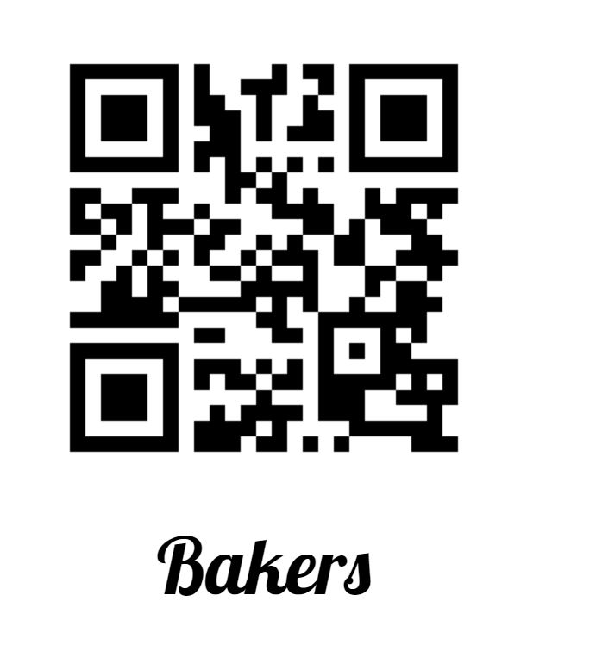

Scan this QR code to open our website to see how you are related. If you have a FamilySearch.org account, you can search as yourself. If not, you can find a deceased ancestor (such as your grandfather) and search as that person.

If you need help getting started, go to map location #2, and someone will be happy to help.

**Find Your Colonial Relatives**



Scan this QR code to open our website to see how you are related. If you have a FamilySearch.org account, you can search as yourself. If not, you can find a deceased ancestor (such as your grandfather) and search as that person.

If you need help getting started, go to map location #2, and someone will be happy to help.

**Find Your Colonial Relatives**



Scan this QR code to open our website to see how you are related. If you have a FamilySearch.org account, you can search as yourself. If not, you can find a deceased ancestor (such as your grandfather) and search as that person.

If you need help getting started, go to map location #2, and someone will be happy to help.

**Find Your Colonial Relatives**



Scan this QR code to open our website to see how you are related. If you have a FamilySearch.org account, you can search as yourself. If not, you can find a deceased ancestor (such as your grandfather) and search as that person.

If you need help getting started, go to map location #2, and someone will be happy to help.

**Find Your Colonial Relatives**

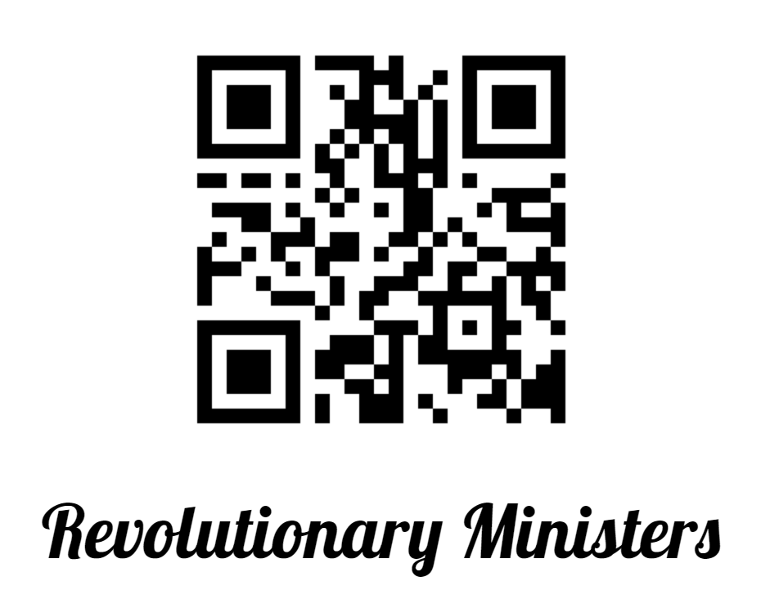

Scan this QR code to open our website to see how you are related. If you have a FamilySearch.org account, you can search as yourself. If not, you can find a deceased ancestor (such as your grandfather) and search as that person.

If you need help getting started, go to map location #2, and someone will be happy to help.

**Find Your Colonial Relatives**



Scan this QR code to open our website to see how you are related. If you have a FamilySearch.org account, you can search as yourself. If not, you can find a deceased ancestor (such as your grandfather) and search as that person.

If you need help getting started, go to map location #2, and someone will be happy to help.

**Find Your Colonial Relatives**



Scan this QR code to open our website to see how you are related. If you have a FamilySearch.org account, you can search as yourself. If not, you can find a deceased ancestor (such as your grandfather) and search as that person.

If you need help getting started, go to map location #2, and someone will be happy to help.

**Find Your Colonial Relatives**



Scan this QR code to open our website to see how you are related. If you have a FamilySearch.org account, you can search as yourself. If not, you can find a deceased ancestor (such as your grandfather) and search as that person.

If you need help getting started, go to map location #2, and someone will be happy to help.

**Find Your Colonial Relatives**



Scan this QR code to open our website to see how you are related. If you have a FamilySearch.org account, you can search as yourself. If not, you can find a deceased ancestor (such as your grandfather) and search as that person.

If you need help getting started, go to map location #2, and someone will be happy to help.

**Find Your Colonial Relatives**



Scan this QR code to open our website to see how you are related. If you have a FamilySearch.org account, you can search as yourself. If not, you can find a deceased ancestor (such as your grandfather) and search as that person.

If you need help getting started, go to map location #2, and someone will be happy to help.

**Find Your Colonial Relatives**



Scan this QR code to open our website to see how you are related. If you have a FamilySearch.org account, you can search as yourself. If not, you can find a deceased ancestor (such as your grandfather) and search as that person.

If you need help getting started, go to map location #2, and someone will be happy to help.